How to request training on an instrument
- Sign in to your account using this link https://eu.ilabsolutions.com/service_center/show_external/3695
- Go to Schedule Equipment
- Choose an item and right click View Schedule and “Open Link in New Tab”, but stay in in this tab.
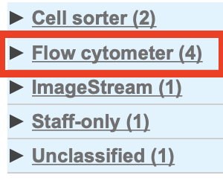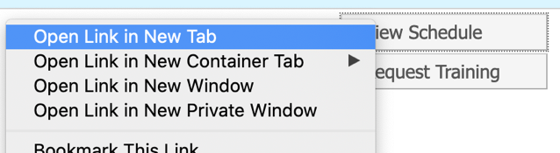
Then click Request Training.
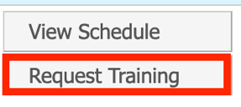
- Click Ok in the pop-up.
- Fill out the application form. Subjects with 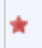 are mandatory.
If you fill out the preferred training date, look for a free date in the tab you opened for View Schedule. Keep in mind this only shows when the instrument is free and not the staff. If we the staff is not available at the suggested time, we will contact you to find a suitable date and time for all.
- Choose project number from the dropdown menu.
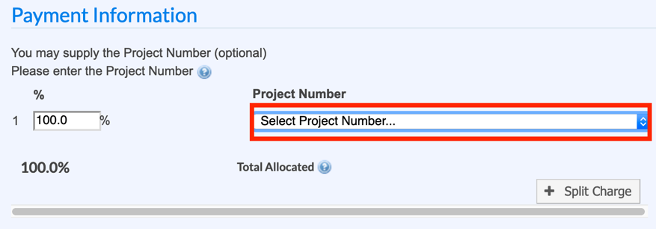
- Click submit request to core.

If you have any questions do not hesitate to contact the FACS Core staff at facs@au.dk.

