Contact FACS Core regarding an existing request in iLab

- Sign in to your account using this link https://eu.ilabsolutions.com/service_center/show_external/3695
- Find your request in the tab “View My Requests” (should be the default when signing in).
You can use the search engine to the left by typing keywords and click Apply Filter.
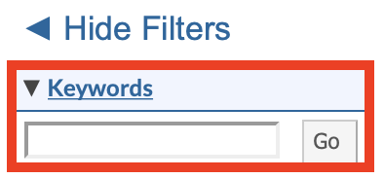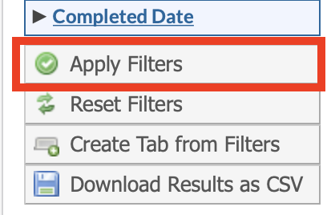
If the request you are looking for has been completed, then click on active request in the upper right corner and choose completed in the menu.
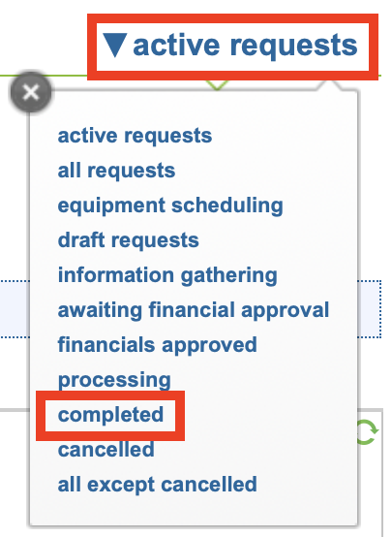
If you have trouble finding your request try using the search engine as described above.
- When you have found your request click the mail icon in the top right of the request.
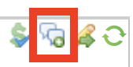
Write your message and make sure that the facs@au.dk mail is chosen.
- Your message will be seen as a comment in the bottom of your request with a history of all comments and messages related to this request, from both you and FACS Core Staff.

If you have any questions do not hesitate to contact the FACS Core staff at facs@au.dk.

