Changing logged time in iLab after using an instrument
- Sign in to your account using this link https://eu.ilabsolutions.com/service_center/show_external/3695
- Go to Schedule Equipment
- Choose an item from the list and click View Schedule on the instrument of choice.
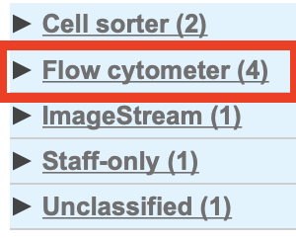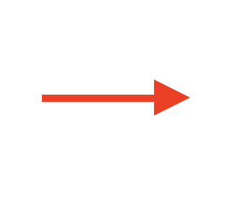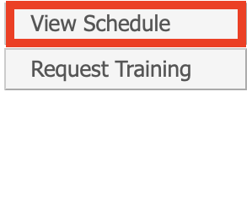
Tip: You can bookmark the calendar of your preferred instruments for easier access, although you still need to sign in with the link above beforehand.
- Find the reservation you want to edit and double-click it.
- Click on the yellow pen next to Logged time
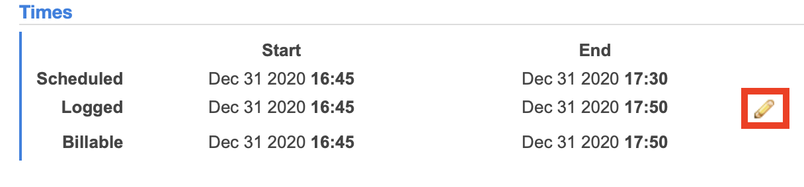
- Change the time according to the time you used and Save the changes.
You will now be billed for logged time instead of scheduled time.

If you have any questions do not hesitate to contact the FACS Core staff at facs@au.dk.

