New request of sorting samples in iLab
- Sign in to your account using this link https://eu.ilabsolutions.com/service_center/show_external/3695
- Go to Request Services.
- Click request service for sorting.
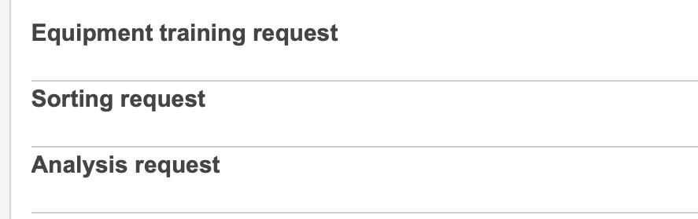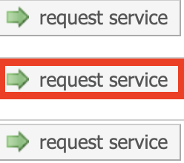
- If we have not performed a similar request from you before click No in the first field.
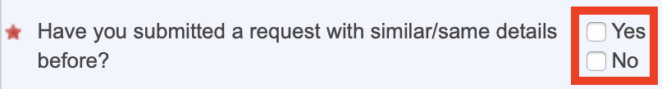
If you have, then click Yes and upload the .pdf file.
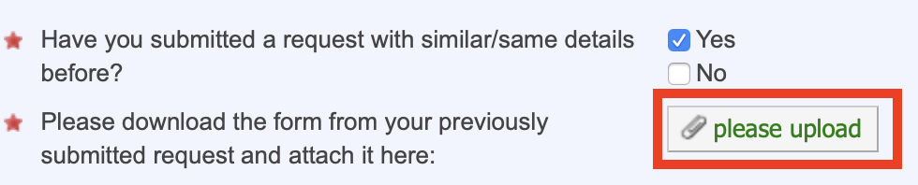
- Fill out the application form. Subjects with are mandatory.
If you do not have all the information right away, you can click 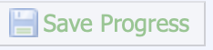in the upper right corner of the application form and return when you have the information.
- Remember to fill out payment information.
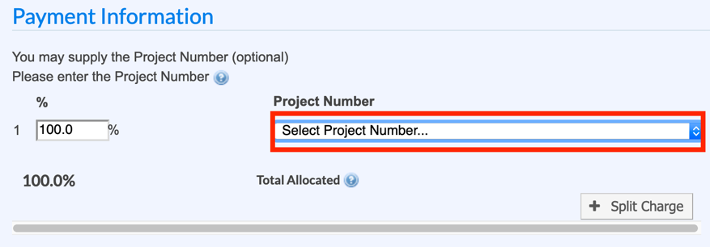
- If you want to download the form for later use click 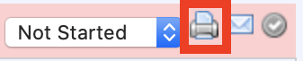in the upper right side.
Click Print and download the .pdf file for possible later use.
- Click submit request to core.

FACS Core Staff will then review your request and start communication if we have any questions. When everything is in order we will accept the request with a preliminary price and wait for your agreement in iLab before executing the task. You can click on the request to see any details.

The exact price of your request will be available after execution.
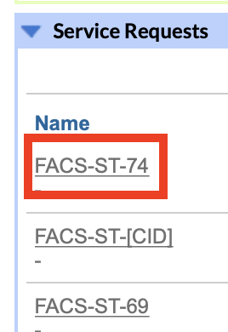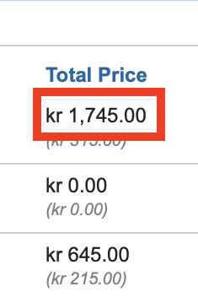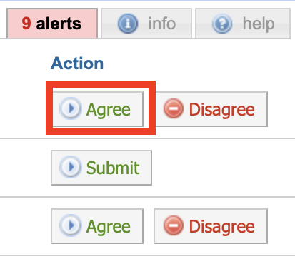

If you have any questions do not hesitate to contact the FACS Core staff at facs@au.dk.
If you have questions regarding an existing request you can contact us by clicking to the right in the overview of your requests in iLab, or 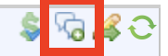 if you have clicked on the request.

It is also possible to contact FACS Core via your former request, as long as it has not been completed in iLab by the staff.

