Make a reservation for instruments in iLab

- Sign in to your account using this link https://eu.ilabsolutions.com/service_center/show_external/3695
- Go to Schedule Equipment
- Choose an item from the list and click View Schedule on the instrument of choice.
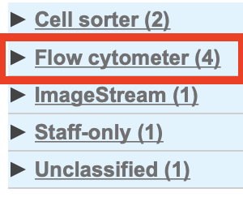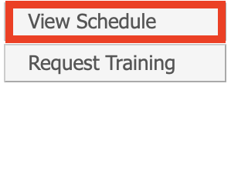
- Choose the date and highlight the requested period in the calendar and a reservation form appears. iLab automatically adds 15-30 minutes at the end of your reservation for cleaning, depending on the instrument. You are not charged for this time.
The highlighted area in the calendar shows when the Core is staffed.
- Type in your phone number in Event notes
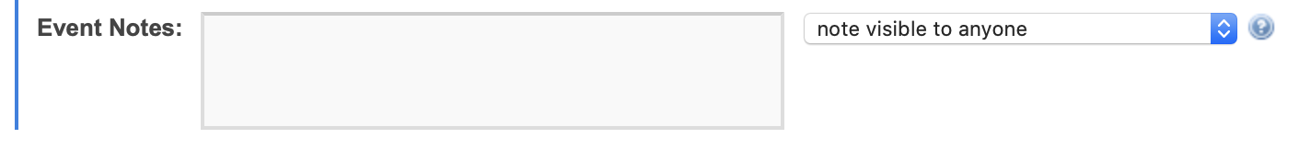
- Check that the reserved time is correct, if not, correct it by clicking the pencil and then click save.
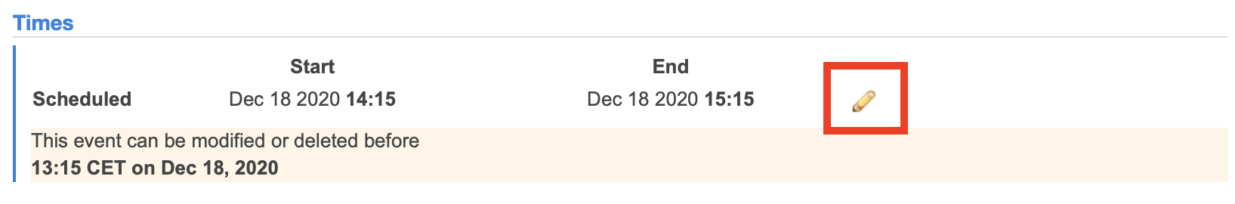
- Make sure the Project number is chosen correctly. If you have more than one project number you can split the charge.
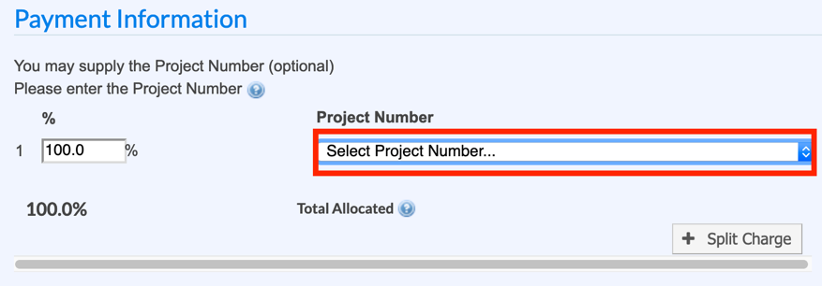
- Click Save Reservation.
You can easily delete your reservations or edit them if you e.g. have used 15 min less. Go to schedule as described above and double click the event in the calendar and choose delete event or change the time.
If you have any questions do not hesitate to contact the FACS Core staff at facs@au.dk.

