How to delete project and activity numbers
- Sign in to your account using this link https://eu.ilabsolutions.com/service_center/show_external/3695
- Go to your lab to clicking the three stripes, then mouseover “My Group” and click on your lab.
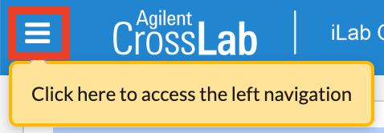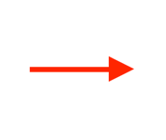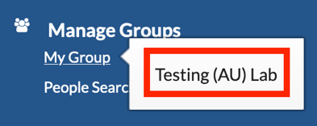
- Go to the “Membership Requests & Project Numbers” tab.
- Click on “Project Numbers”.
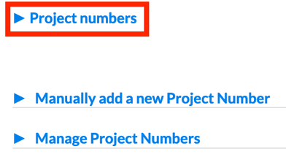
- Uncheck the project number in question for all employees that are linked to it.
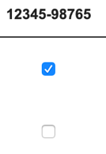
Refresh the webpage.
- Click on “Manage Project Numbers”.
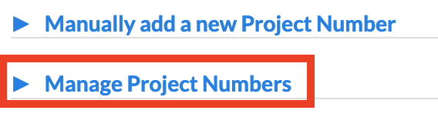
- Find the project number you want to delete and click the red cross in its line.

If you have any questions do not hesitate to contact the FACS Core staff at facs@au.dk.

