How to add your EAN number
- Sign in to your account.
- Go to your lab by clicking the three stripes, then mouseover “My Group” and click on your lab.
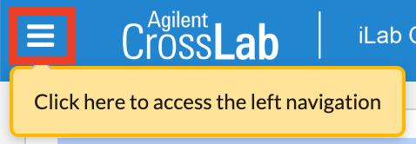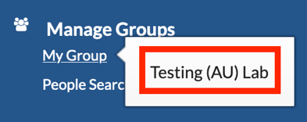
- Go top Group Settings.

- Click on edit under General Lab Information.
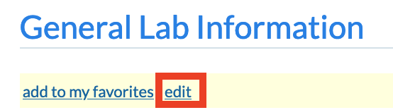

- In the textbox with your lab name enter a space, followed by a hyphen, followed by a space and then enter your 13 digit EAN number.
Example: Testing lab name – 5798000418486
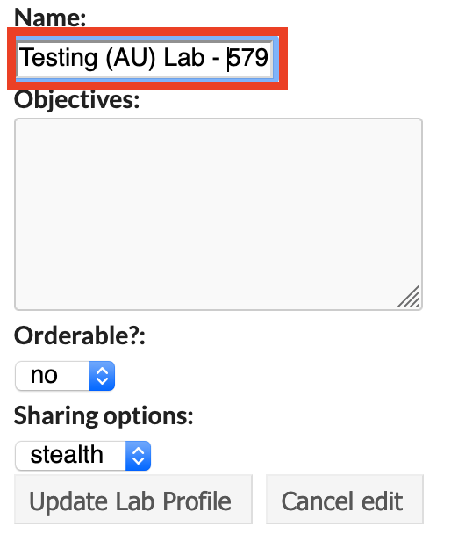

- Click Update Lab Profile.
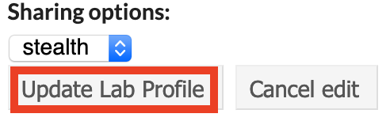

If you have any questions do not hesitate to contact the FACS Core staff at facs@au.dk.

