How to add a new employee to your lab
First, make sure that the employee in question has created an iLab account.
- Sign in to your account using this link https://eu.ilabsolutions.com/service_center/show_external/3695
- Go to your lab to clicking the three stripes, then mouseover “My Group” and click on your lab.
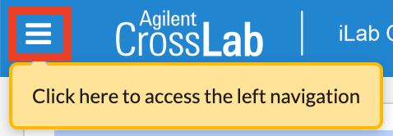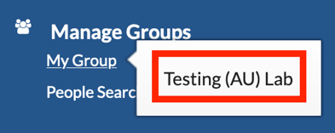
- Go to the “Members” tab.
- Click “Link Existing User” and enter the name of the employee and click it.
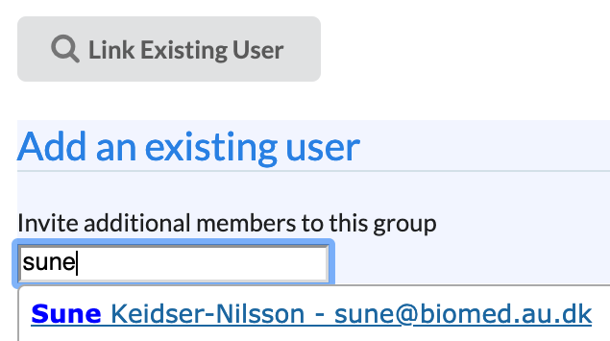
- Choose their membership (member, manager or principal investigator).
- If you do not choose a start date the membership will be active immediately.
- If you do not choose an end date the membership will remain active indefinitely (you can always remove them from your group under the Members tab).
- Click Invite.
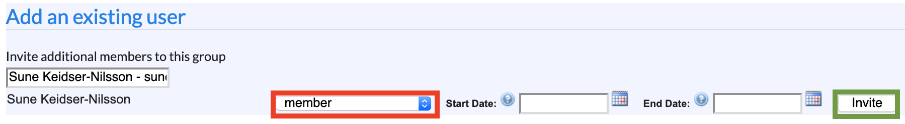

If you have any questions do not hesitate to contact the FACS Core staff at facs@au.dk.

