How to set up a financial auto-approval threshold for your lab
- Sign in to your account using this link https://eu.ilabsolutions.com/service_center/show_external/3695
- Go to your lab by clicking the three stripes, then mouseover “My Group” and click on your lab.
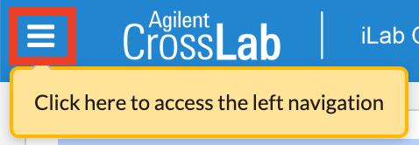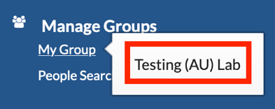
- Go to the Members tab
- There are two approval settings:
Default auto-approval threshold: Any request from one of your employees to the FACS Core Facility that has a cost below this amount, will be financially approved automatically.
- Any request above this amount will need manual approval from you.
Cost overage buffer: This setting is usually set to 0, which we recommend.
- Adjust the amounts to your preference and click “save approval settings”.

How to set up a financial auto-approval threshold for an individual
- Go to the Members tab
- Under Lab members and settings find the individual, then clickin the right side of the field.
- Enter your desired threshold in the Auto Approval Amount field and click save.
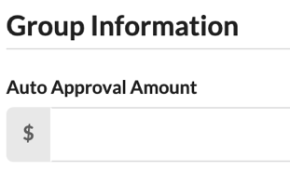

If you have any questions do not hesitate to contact the FACS Core staff at facs@au.dk.

