How to add project-activity numbers and assign to your employees
- Sign in to your account using this link https://eu.ilabsolutions.com/service_center/show_external/3695
- Go to your lab to clicking the three stripes, then mouseover “My Group” and click on your lab.
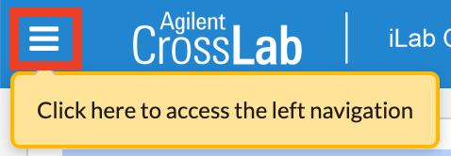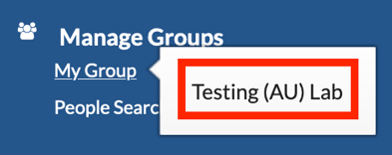
- Go to the “Membership Requests & Project Numbers” tab.
- Click on “Manually add a new Project Number”
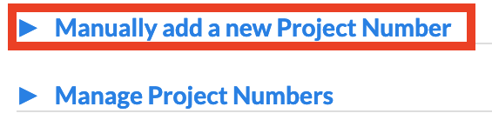
- Enter the 5-digit project number followed by a hyphen and enter the 5-digit activity number. No space between numbers and hyphen.
Example: 12345-26101
If you do not follow this format exactly, iLab will pop up with an error message.
- Click Add.
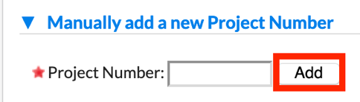
- The newly added project number is now visible in the right side of the screen.
Mark the checkbox for each employee that is going to use this project number.
- It is possible to set the default project number for the different employees. 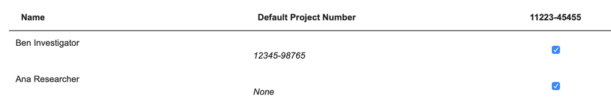

If you have any questions do not hesitate to contact the FACS Core staff at facs@au.dk.

