Create a user profile in iLab

- Go to: https://eu.ilabsolutions.com/service_center/show_external/3695
- In the upper right hand corner click 'Register'
- Enter your work email address
- Under personal information fill in all information including phone number.
- Under I am affiliated with the following institution, choose Aarhus University or Aarhus University Hospital.
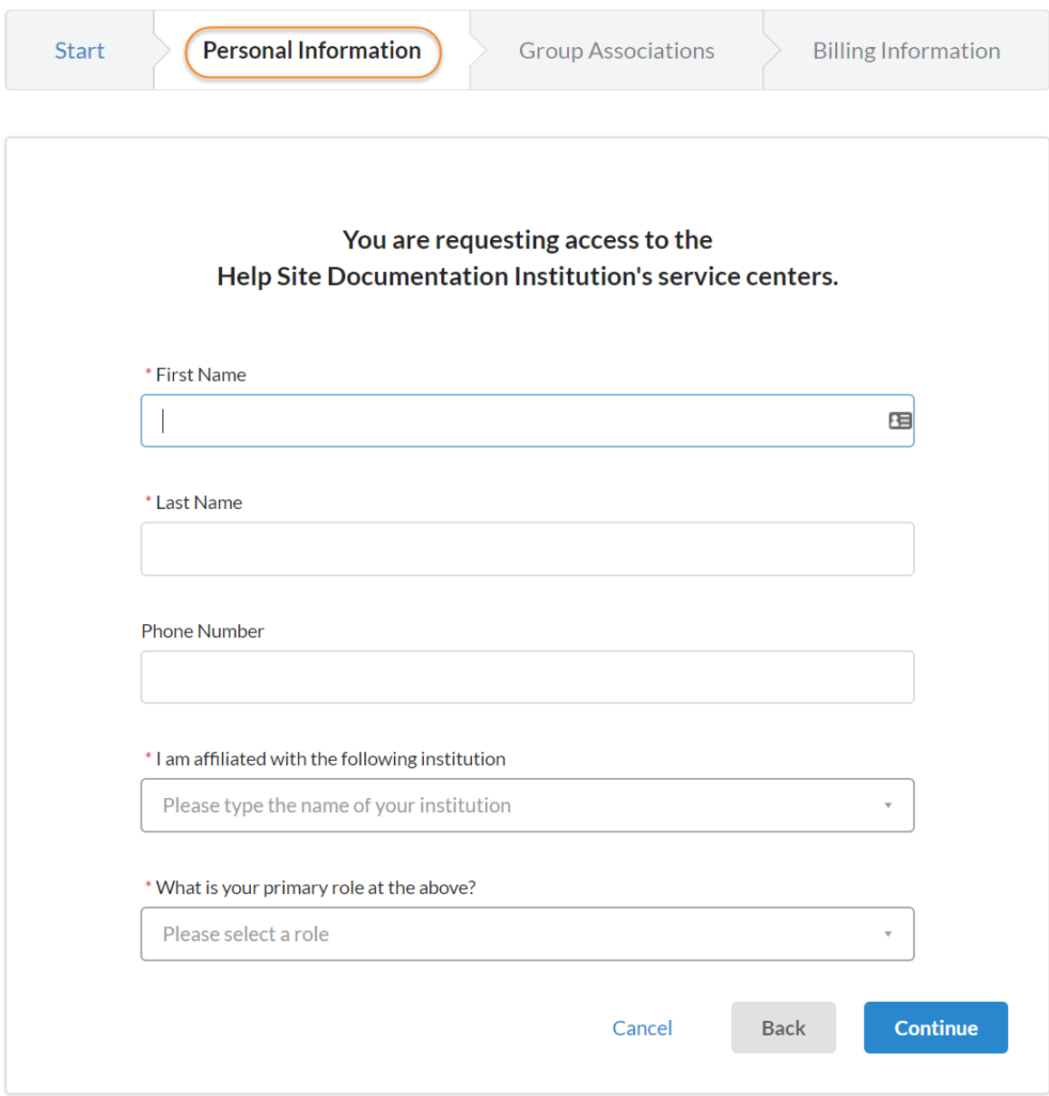

- Under Group Association enter the name of your PI, please do not use a group name. The system will search for your PIs name. If he/she does not exist in the system yet, click "Create New Group" to create a new Lab/Group with the name of your PI.
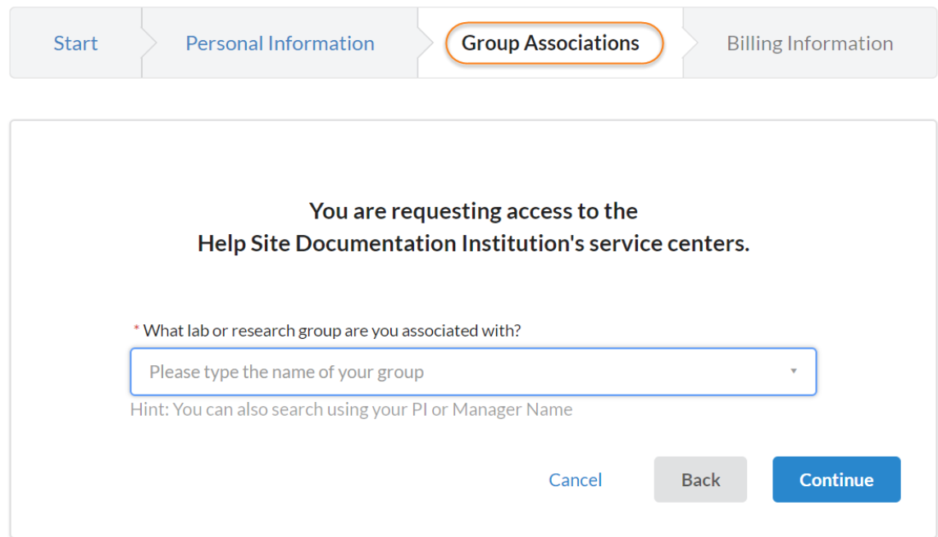

- If someone else but the PI is the one to handle lab memberships and fund assignments information click yes in the that box:
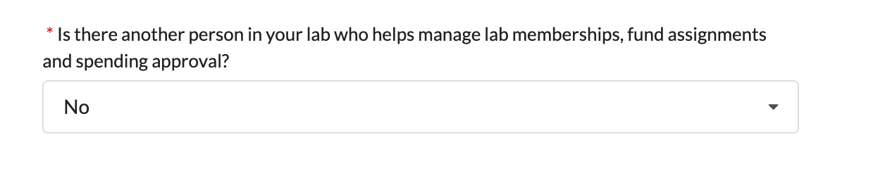
- New boxes to fill out unfolds.
- Fill out all requested information.
- Press complete.
- You and your PI and/or Lab/group manager will receive a confirmation email within 24 hours.
- We highly recommend that you also adjust your notification settings.
FOR PI’s / lab managers
All AU PIs must add their EAN into their lab name . Follow the guide with this link How to add an EAN number .
- We highly recommend that you go through your notification settings (just below “Billing/shipping information”).
- If you would prefer to delegate these notifications/approvals to a financial manager, make sure they are registered in iLab and send an email to facs@au.dk with your group name and name of the manager.
- For a guide to manage group members and project numbers please go to How to add project and activity numbers

